Lab – Calculating Summary Routes with IPv4 and IPv6 (Instructor Version)

**Instructor Note**: Red font color or Gray highlights indicate text that appears in the instructor copy only.

1. Topology

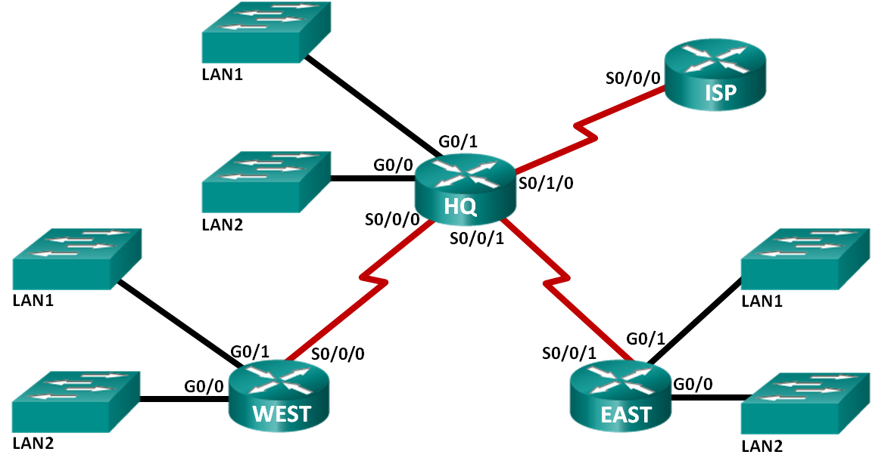

1. Addressing Table

|  |  |  |
| --- | --- | --- |
| Subnet | IPv4 Address | IPv6 Address |
| HQ LAN1 | 192.168.64.0/23 | 2001:DB8:ACAD:E::/64 |
| HQ LAN2 | 192.168.66.0/23 | 2001:DB8:ACAD:F::/64 |
| EAST LAN1 | 192.168.68.0/24 | 2001:DB8:ACAD:1::/64 |
| EAST LAN2 | 192.168.69.0/24 | 2001:DB8:ACAD:2::/64 |
| WEST LAN1 | 192.168.70.0/25 | 2001:DB8:ACAD:9::/64 |
| WEST LAN2 | 192.168.70.128/25 | 2001:DB8:ACAD:A::/64 |
| Link from HQ to EAST | 192.168.71.4/30 | 2001:DB8:ACAD:1000::/64 |
| Link from HQ to WEST | 192.168.71.0/30 | 2001:DB8:ACAD:2000::/64 |
| Link from HQ to ISP | 209.165.201.0/30 | 2001:DB8:CC1E:1::/64 |

1. Objectives

Part 1: Calculate IPv4 Summary Routes

* Determine the summary route for the HQ LANs.
* Determine the summary route for the EAST LANs.
* Determine the summary route for the WEST LANs.
* Determine the summary route for the HQ, EAST, and WEST LANs.

Part 2: Calculate IPv6 Summary Routes

* Determine the summary route for the HQ LANs.
* Determine the summary route for the EAST LANs.
* Determine the summary route for the WEST LANs.
* Determine the summary route for the HQ, EAST, and WEST LANs.

1. Background / Scenario

Summary routes reduce the number of entries in routing tables and make the routing table lookup process more efficient. This process also reduces the memory requirements for the router. A single static route can be used to represent a few routes or thousands of routes.

In this lab, you will determine the summary routes for different subnets of a network. You will then determine the summary route for the entire network. Summary routes will be determined for both IPv4 and IPv6 addresses. Because IPv6 uses hexadecimal (hex) values, you will be required to convert hex to binary.

**Instructor Note**: This activity can be done in class or assigned as homework. If the assignment is done in class, you may wish to have students work alone or in teams of two students each. It is suggested that the first problem be done together in class to give students guidance as to how to proceed for the rest of the assignment.

1. Required Resources

* 1 PC (Windows 7, Vista, or XP with Internet access)
* Optional: calculator for converting hex and decimal to binary

1. Calculate IPv4 Summary Routes

In Part 1, you will determine summarized routes that can be used to reduce the size of routing tables. Fill in the tables, after each set of steps, with the appropriate IPv4 addressing information.

* 1. List the HQ LAN1 and HQ LAN2 IP subnet mask in decimal form.
  2. List the HQ LAN1 and HQ LAN2 IP address in binary form.
  3. Count the number of far left matching bits to determine the subnet mask for the summary route.
     1. How many far left matching bits are present in the two networks? _____________ 22
     2. List the subnet mask for the summary route in decimal form.
  4. Copy the matching binary bits and then add all zeros to determine the summarized network address.
     1. List the matching binary bits for HQ LAN1 and HQ LAN2 subnets.
     2. Add zeros to comprise the remainder of the network address in binary form.
     3. List the summarized network address in decimal form.

|  |  |  |  |
| --- | --- | --- | --- |
| Subnet | IPv4 Address | Subnet Mask | Subnet IP Address in Binary Form |
| HQ LAN1 | 192.168.64.0 | 255.255.254.0 | 11000000.10101000.01000000.00000000 |
| HQ LAN2 | 192.168.66.0 | 255.255.254.0 | 11000000.10101000.01000010.00000000 |
| HQ LANs Summary Address | 192.168.64.0 | 255.255.252.0 | 11000000.10101000.01000000.00000000 |

* 1. List the EAST LAN1 and EAST LAN2 IP subnet mask in decimal form.
  2. List the EAST LAN1 and EAST LAN2 IP address in binary form.
  3. Count the number of far left matching bits to determine the subnet mask for the summary route.
     1. How many far left matching bits are present in the two networks? _____________ 23
     2. List the subnet mask for the summary route in decimal form.
  4. Copy the matching binary bits and then add all zeros to determine the summarized network address.
     1. List the matching binary bits for EAST LAN1 and EAST LAN2 subnets.
     2. Add zeros to comprise the remainder of the network address in binary form.
     3. List the summarized network address in decimal form.

|  |  |  |  |
| --- | --- | --- | --- |
| Subnet | IPv4 Address | Subnet Mask | Subnet Address in Binary Form |
| EAST LAN1 | 192.168.68.0 | 255.255.255.0 | 11000000.10101000.01000100.00000000 |
| EAST LAN2 | 192.168.69.0 | 255.255.255.0 | 11000000.10101000.01000101.00000000 |
| EAST LANs Summary Address | 192.168.68.0 | 255.255.254.0 | 11000000.10101000.01000100.00000000 |

* 1. List the WEST LAN1 and WEST LAN2 IP subnet mask in decimal form.
  2. List the WEST LAN1 and WEST LAN2 IP address in binary form.
  3. Count the number of far left matching bits to determine the subnet mask for the summary route.
     1. How many far left matching bits are present in the two networks? _____________ 24
     2. List the subnet mask for the summary route in decimal form.
  4. Copy the matching binary bits and then add all zeros to determine the summarized network address.
     1. List the matching binary bits for WEST LAN1 and WEST LAN2 subnets.
     2. Add zeros to comprise the remainder of the network address in binary form.
     3. List the summarized network address in decimal form.

|  |  |  |  |
| --- | --- | --- | --- |
| Subnet | IPv4 Address | Subnet Mask | Subnet IP Address in Binary Form |
| WEST LAN1 | 192.168.70.0 | 255.255.255.128 | 11000000.10101000.01000110.00000000 |
| WEST LAN2 | 192.168.70.128 | 255.255.255.128 | 11000000.10101000.01000110.10000000 |
| WEST LANs Summary Address | 192.168.70.0 | 255.255.255.0 | 11000000.10101000.01000110.00000000 |

* 1. List the HQ, EAST, and WEST summary route IP address and subnet mask in decimal form.
  2. List the HQ, EAST, and WEST summary route IP address in binary form.
  3. Count the number of far left matching bits to determine the subnet mask for the summary route.
     1. How many far left matching bits are present in the three networks? _____________ 21
     2. List the subnet mask for the summary route in decimal form.
  4. Copy the matching binary bits and then add all zeros to determine the summarized network address.
     1. List the matching binary bits for HQ, EAST, and WEST subnets.
     2. Add zeros to comprise the remainder of the network address in binary form.
     3. List the summarized network address in decimal form.

|  |  |  |  |
| --- | --- | --- | --- |
| Subnet | IPv4 Address | Subnet Mask | Subnet IP Address in Binary Form |
| HQ | 192.168.64.0 | 255.255.252.0 | 11000000.10101000.01000000.00000000 |
| EAST | 192.168.68.0 | 255.255.254.0 | 11000000.10101000.01000100.00000000 |
| WEST | 192.168.70.0 | 255.255.255.0 | 11000000.10101000.01000110.00000000 |
| Network Address Summary Route | 192.168.64.0 | 255.255.248.0 | 11000000.10101000.01000000.00000000 |

1. Calculate IPv6 Summary Routes

In Part 2, you will determine summarized routes that can be used to reduce the size of routing tables. Complete the tables after each set of steps, with the appropriate IPv6 addressing information.

1. Topology



1. Addressing Table

|  |  |
| --- | --- |
| Subnet | IPv6 Address |
| HQ LAN1 | 2001:DB8:ACAD:E::/64 |
| HQ LAN2 | 2001:DB8:ACAD:F::/64 |
| EAST LAN1 | 2001:DB8:ACAD:1::/64 |
| EAST LAN2 | 2001:DB8:ACAD:2::/64 |
| WEST LAN1 | 2001:DB8:ACAD:9::/64 |
| WEST LAN2 | 2001:DB8:ACAD:A::/64 |
| Link from HQ to EAST | 2001:DB8:ACAD:1000::/64 |
| Link from HQ to WEST | 2001:DB8:ACAD:2000::/64 |
| Link from HQ to ISP | 2001:DB8:CC1E:1::/64 |

* 1. List the first 64 bits of the HQ LAN1 and HQ LAN2 IP subnet mask in hexadecimal form.
  2. List the HQ LAN1 and HQ LAN2 subnet ID (bits 48-64) in binary form.
  3. Count the number of far left matching bits to determine the subnet mask for the summary route.
     1. How many far left matching bits are present in the two subnet IDs? _____________ 63
     2. List the subnet mask for the first 64 bits of the summary route in decimal form.
  4. Copy the matching binary bits and then add all zeros to determine the summarized network address.
     1. List the matching subnet ID binary bits for HQ LAN1 and HQ LAN2 subnets.
     2. Add zeros to comprise the remainder of the subnet ID address in binary form.
     3. List the summarized network address in decimal form.

|  |  |  |  |
| --- | --- | --- | --- |
| Subnet | IPv6 Address | Subnet Mask for First 64 bits | Subnet ID in Binary Form |
| HQ LAN1 | 2001:DB8:ACAD:E::/64 | FFFF:FFFF:FFFF:FFFF | 0000000000001110 |
| HQ LAN2 | 2001:DB8:ACAD:F::/64 | FFFF:FFFF:FFFF:FFFF | 0000000000001111 |
| HQ LANs Summary Address | 2001:DB8:ACAD:E::/63 | FFFF:FFFF:FFFF:FFFE | 0000000000001110 |

* 1. List the first 64 bits of the EAST LAN1 and EAST LAN2 IP subnet mask in hexadecimal form.
  2. List the EAST LAN1 and EAST LAN2 subnet ID (bits 48-64) in binary form.
  3. Count the number of far left matching bits to determine the subnet mask for the summary route.
     1. How many far left matching bits are present in the two subnet IDs? _____________ 62
     2. List the subnet mask for the first 64 bits of the summary route in decimal form.
  4. Copy the matching binary bits and then add all zeros to determine the summarized network address.
     1. List the matching binary bits for EAST LAN1 and EAST LAN2 subnets.
     2. Add zeros to comprise the remainder of the subnet ID address in binary form.
     3. List the summarized network address in decimal form.

|  |  |  |  |
| --- | --- | --- | --- |
| Subnet | IPv6 Address | Subnet Mask for First 64 bits | Subnet ID in Binary Form |
| EAST LAN1 | 2001:DB8:ACAD:1::/64 | FFFF:FFFF:FFFF:FFFF | 0000000000000001 |
| EAST LAN2 | 2001:DB8:ACAD:2::/64 | FFFF:FFFF:FFFF:FFFF | 0000000000000010 |
| EAST LANs Summary Address | 2001:DB8:ACAD::/62 | FFFF:FFFF:FFFF:FFFC | 0000000000000000 |

* 1. List the first 64 bits of the WEST LAN1 and WEST LAN2 IP subnet mask in decimal form.
  2. List the WEST LAN1 and WEST LAN2 subnet ID (bits 48-64) in binary form.
  3. Count the number of far left matching bits to determine the subnet mask for the summary route.
     1. How many far left matching bits are present in the two subnet IDs? _____________ 62
     2. List the subnet mask for the first 64 bits of the summary route in decimal form.
  4. Copy the matching binary bits and then add all zeros to determine the summarized network address.
     1. List the matching binary bits for WEST LAN1 and WEST LAN2 subnets.
     2. Add zeros to comprise the remainder of the subnet ID address in binary form.
     3. List the summarized network address in decimal form.

|  |  |  |  |
| --- | --- | --- | --- |
| Subnet | IPv6 Address | Subnet Mask for First 64 bits | Subnet ID in Binary Form |
| WEST LAN1 | 2001:DB8:ACAD:9::/64 | FFFF:FFFF:FFFF:FFFF | 0000000000001001 |
| WEST LAN2 | 2001:DB8:ACAD:A::/64 | FFFF:FFFF:FFFF:FFFF | 0000000000001010 |
| WEST LANs Summary Address | 2001:DB8:ACAD:8::/62 | FFFF:FFFF:FFFF:FFFC | 0000000000001000 |

* 1. List the HQ, EAST, and WEST summary route IP address and the first 64 bits of the subnet mask in decimal form.
  2. List the HQ, EAST, and WEST summary route subnet ID in binary form.
  3. Count the number of far left matching bits to determine the subnet mask for the summary route.
     1. How many far left matching bits are present in the three subnet IDs? _____________ 60
     2. List the subnet mask for the first 64 bits of the summary route in decimal form.
  4. Copy the matching binary bits and then add all zeros to determine the summarized network address.
     1. List the matching binary bits for HQ, EAST, and WEST subnets.
     2. Add zeros to comprise the remainder of the subnet ID address in binary form.
     3. List the summarized network address in decimal form.

|  |  |  |  |
| --- | --- | --- | --- |
| Subnet | IPv6 Address | Subnet Mask for first 64 bits | Subnet ID in Binary Form |
| HQ | 2001:DB8:ACAD:E::/63 | FFFF:FFFF:FFFF:FFFE | 0000000000001110 |
| EAST | 2001:DB8:ACAD::/62 | FFFF:FFFF:FFFF:FFFC | 0000000000000000 |
| WEST | 2001:DB8:ACAD:8::/62 | FFFF:FFFF:FFFF:FFFC | 0000000000001000 |
| Network Address Summary Route | 2001:DB8:ACAD::/60 | FFFF:FFFF:FFFF:FFF0 | 0000000000000000 |

1. Reflection
   1. How is determining the summary route for IPv4 different from IPv6?

_______________________________________________________________________________________

_______________________________________________________________________________________

_______________________________________________________________________________________

There is no major difference except that IPv4 is 32 bit and IPv6 is 128 bit. Also, IPv4 is converted from decimal to binary and IPv6 is converted from hex to binary.

* 1. Why are summary routes beneficial to a network?

_______________________________________________________________________________________

_______________________________________________________________________________________

_______________________________________________________________________________________

Makes the routing table lookup process more efficient and reduces the memory requirements for the router.